Get a Blog

In Chrome or Firefox, go to http://edublogs.eanesisd.net/

Click “Get a blog/log in”
Log in with your EISD username and password (Ex: TK12345@eanesisd.net and Cats****)

At the top of the screen, you will see this:

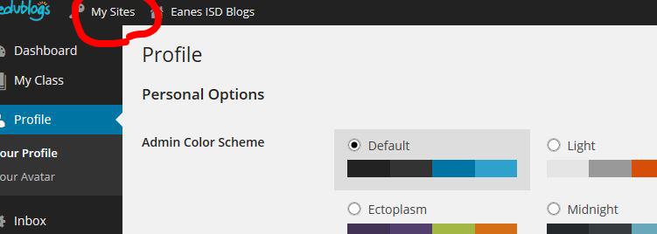

Hover over “My Sites” and select your own blog’s dashboard.

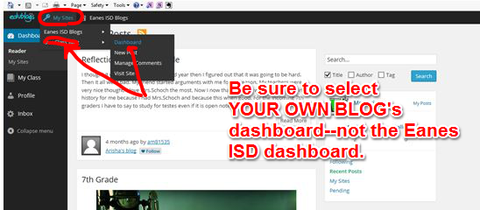

From DASHBOARD, look down the left side column and select
SETTINGS
GENERAL
- Fill in title of your blog. Create a blog title that starts
with your first name: ex: Tracy’s Blog or Tracy’s Talk
- Fill in tagline of your blog. This is like a subtitle. Some people use a favorite quote. Others leave an invitation to read or a message of welcome. Leave this blank if you don’t want a tagline.
- Set timezone to UTC -5 (minus 5)
- SAVE CHANGES

From DASHBOARD, look down left side column and select
USERS
YOUR PROFILE
- DO NOT change your username
- DO NOT change your password
- Change the NICKNAME to your first name, last initial, class period EX: tracyk2
- Use dropdown “Display Name Publicly As” to select your newly created NICKNAME. This is required.
- Save changes

From DASHBOARD, select
POSTS
ALL POSTS
HELLO WORLD
- Hover over the HELLO WORLD
- Click the word “trash” to put it in the trash

From DASHBOARD, select
PAGES
ALL PAGES
SAMPLE PAGE
- Hover over the SAMPLE PAGE
- Click the word “trash” to put it in the trash

The next step for today is joining your teacher’s class blog.
Go to DASHBOARD
MY CLASS
JOIN A CLASS
- search for tkriese
- click “send a request to join”
- Mrs. Kriese will accept you into the class via the class blog dashboard.

From DASHBOARD, select
APPEARANCE
THEMES
There are over 200 themes to choose from! However, these are key points to keep in mind as you choose your theme:

Your theme must give your visitors the ability to easily find their way around from the front page. This means you may NOT choose these three hard-to-navigate themes:

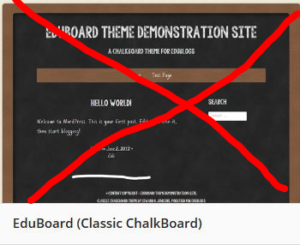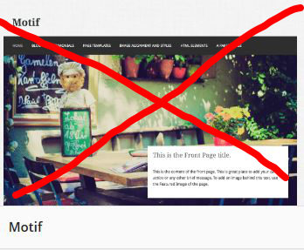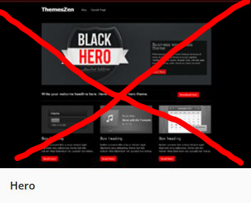

You may choose a one-column theme like the ones below, but notice that because there is no sidebar--only a footer area--all your links, your visitors map, and any fun widgets like virtual pets will only be visible at the bottom of your blog. Visitors will have to scroll to the bottom to find these things.

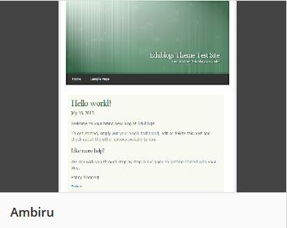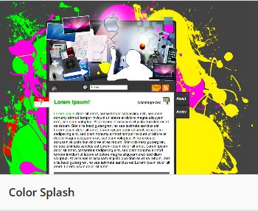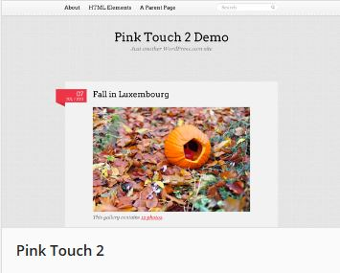

You may use a photo-showcase, magazine layout theme like those below, but your blog won’t look very good until you a) write several posts that use photos and b) learn how to use the “set featured image” option for photos. That lesson will be at the end of next week.
Suggestion: Choose a non-magazine, non-photo gallery theme for the first few weeks until you have more content and many photos, THEN switch to a theme that will showcase that content. Changing themes is as easy as a few clicks of the keyboard.

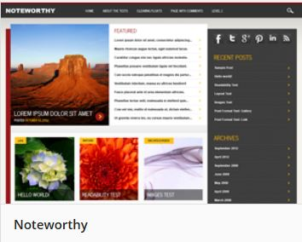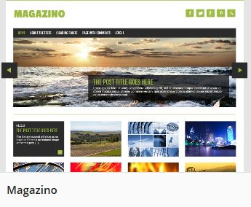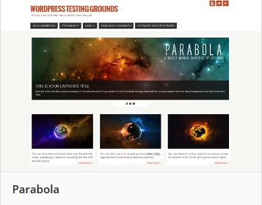

After you have chosen your theme, click ACTIVATE.

Congratulations! Your blog is up and running!

