Video Embed
Think about something you have learned to do: a sport, a hobby, or a skill.
Go to YouTube and find a video that demonstrates your learning:
· http://youtube.com

1. When you find the video you want, click “share.”

2. Click “embed.”

3. Choose the smallest size option so that it will fit your blog. Some blogs are narrow and will need a custom size. If your posted video overlaps into your sidebar, YOU WILL BE EXPECTED TO GO BACK AND RE-SIZE YOUR VIDEO SO THAT IT FITS! Use the custom size option to make it even smaller.

4. UNCHECK “show suggested videos when the video finishes.” If you skip this step, it will affect your grade.

5. Copy the embed code.

6. Go to your post box and choose “TEXT” tab instead of “VISUAL” tab. You are going to paste an HTML code, and it will only be “read” in this text box.

7. Paste your embed code into the text box. Add any additional writing you want for your post.

8. Check your post category (you may need to create one that suits), and click publish. Do not go back to VISUAL before publishing.

9. View your post to make sure your published video plays correctly and that it fits your blog. If your video overlaps into your sidebar, go back to EDIT.

10. In the code, you will see the dimensions for the length and width of the video. Change those dimensions so that your video will be a smaller size. Then click UPDATE and view your post again to make sure everything looks good.

HYPERLINKS

A hyperlink in your post connects a word or group of words to a website that supports or enriches your post.

When should you use a hyperlink?
- to link a person’s name to that person’s blog
- to link a person’s post or your own, earlier post if you are referring to it
- to link a website or article that supports your post
ASSIGNMENT: Find a website that relates to your video post about your learning. Use a hyperlink to connect the website to that blog post.

HERE ARE THE DIRECTIONS PROVIDED BY EDUBLOGS.ORG:

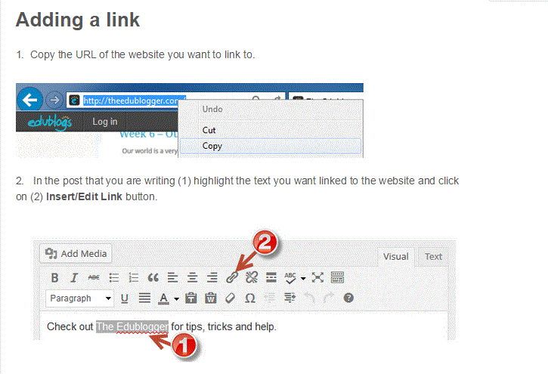
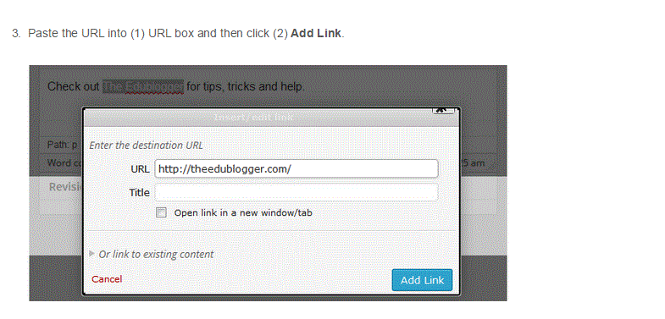
Leave the title field blank.
CHECK THE BOX that says “open in a new window/tab.” Then ADD LINK.

SAVE and VIEW your post. Check your link to make sure it opens in a new window.

