Creating a Blog Avatar

An AVATAR is a visual representation of you.

Your BLOG AVATAR will show on the front page of your blog.

Go to http://pickaface.net and create your avatar.

DO NOT SIGN IN OR REGISTER with the site in order to save your avatar.
Instead, use the snipping tool (found by clicking Windows menu of the school computer) to clip and save your image to your home folder.

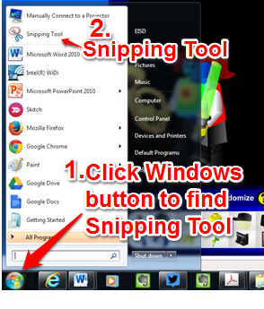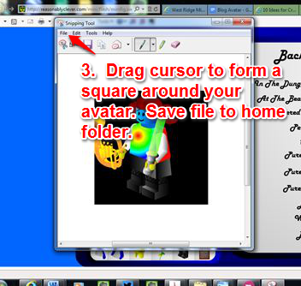
If you are on a computer that does not have a snipping tool, take a screen shot (PrntScrn button) and crop your avatar. Want this tool on your own computer? All Windows 7 operating systems come with the Snipping Tool (search applications to find it); other operating systems can support download and installation of the tool.

Avatar tip:

Most online avatar tools create rectangular images whereas your user and blog avatar are square. When you use the crop your image from the screen, crop and save a square shape.

Uploading your Blog Avatar
The following instructions are from The Edublogger website.

Uploading your blog avatar is as simple as:

1. Resize your image to 200 pixels wide by 200 pixels high (recommended, but not always necessary).

2. Go to Settings > Blog Avatar.

3. Click on Browse and locate the avatar you have saved.

4. Click on Upload.
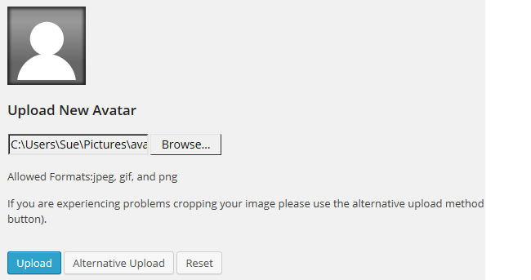
IF YOUR IMAGE WILL NOT UPLOAD, CLICK ON THE “ALTERNATIVE UPLOAD” BUTTON (it’s right next to the blue UPLOAD button).

5. Move the crop area to one corner, then expand the crop area to include your full image and click Crop image.
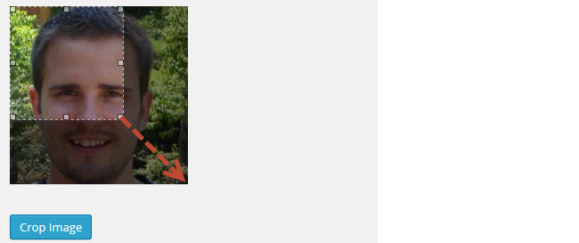

6. Go to Appearance > Widgets.

7. Drag the Blog Avatar widget from the Available Widgets into the desired Sidebar (NOTE: If you were in class on Tuesday, we already did steps #6 through #9)
You drag by click on the widget with your left mouse and moving the widget.
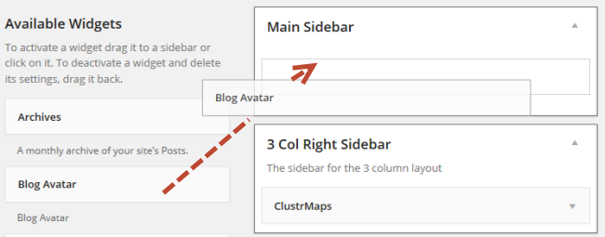
9. Drop the widget when you see a dashed line appear – this indicates the widget is in place.
10. When you view your blog you’ll now see your blog avatar displayed in the sidebar.

