Creative Commons Overview

http://youtu.be/8YkbeycRa2A

There are some situations in which a person can legally use copyrighted images:

Fair Use

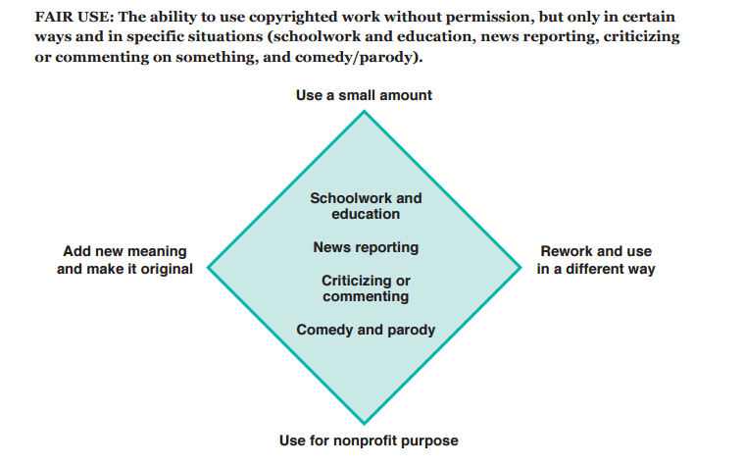

Image via Common Sense Media

Note that “fair use” is a defense, not a right. Photographers are within their rights to challenge your use of their images, but you could defend yourself based on “fair use” doctrine. It is probable (though not guaranteed) that a judge would side with you...IF you stayed within the guidelines above.

